* **Vision Based Road Lane Detection System for Vehicles Guidance**

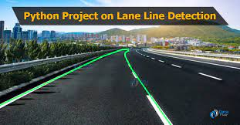

**Abstract:**

Driver support system is one of the most important feature of the modern vehicles to ensure driver safety and decrease vehicle accident on roads. Apparently, the road lane detection or road boundaries detection is the complex and most challenging tasks. It is includes the localization of the road and the determination of the relative position between vehicle and road. A vision system using on-board camera looking outwards from the windshield is presented in this paper. The system acquires the front view using a camera mounted on the vehicle and detects the lanes by applying few processes. The lanes are extracted using Hough transform through a pair of hyperbolas which are fitted to the edges of the lanes. The proposed lane detection system can be applied on both painted and unpainted roads as well as curved and straight road in different weather conditions. The proposed system does not require any extra information such as lane width, time to lane crossing and offset between the center of the lanes. In addition, camera calibration and coordinate transformation are also not required. The system was investigated under various situations of changing illumination, and shadows effects in various road types without speed limits. The system has demonstrated a robust performance for detecting the road lanes under different conditions.

**INTRODUCTION**

Advanced Driving Assistance Systems (ADAS) require the ability to model the shape of road lanes and localize the vehicle with respect to the road. Although, the main reason to build intelligent vehicles is to improve the safety conditions by the entire or partial automation of driving tasks. Among these tasks, the road detection took an important role in driving assistance systems that provides information such as lane structure and vehicle position relative to the lane. However, vehicle crashes remains the leading cause of accident death and injuries in Malaysia and Asian countries which claiming tens of thousands of lives and injuring millions of people each year. Most of these transportation deaths and injuries occur on the nation’s highways. The United Nations has ranked Malaysia as 30th among countries with the highest number of fatal road accidents, registering an average of 4.5 deaths per 10,000 registered vehicles (Benozzi et al., 2002). Therefore, a system that provides a means of warning to a driver for a danger has been considered as a potential way to save a considerable number of lives. One of the main technology involves in these tasks is computer vision which becomes a powerful tool for sensing the environment and has been widely used in many applications by the intelligent transportation systems (ITS). In some proposed systems such as Tsugawa and Sadayuki, (1994), the lane detection consists of the localization of specific primitives such as the road markings of the surface of painted roads. Some systems achieves good results, but detecting the road lane remains a challenging task under adverse conditions (heavy rain, degraded lane markings, adverse meteorological and lighting conditions)that are often met in real driving situations. Under such conditions, the system should at least switch off automatically and not report a false detection, nevertheless, two situations can disturb the process. The presence of other vehicles on the same lane may occlude partially the road markings ahead of the vehicle are the presence of shadows caused by trees, buildings etc. This paper presents a vision- based approach which is capable of reaching a real time performance in detecting and tracking of structured road boundaries with slight curvature and shadow conditions. Road boundaries are detected by fitting a parallel hyperbola pairs to the edges of the lane after applying the edge detection and Hough transform. The vehicle is supposed to move on a flat and straight road or with slow curvature.

**Problem statement:**  Developing the AI based road lane line detection.

**Objectives**: One aspect of automation that **we** share with these autonomous systems is **road lane detection**. For Keep Tracking purposes, **lane detection** is critical in identifying and ensuring safe driving practices. ... Fleet managers can **use** such data to monitor and subsequently educate drivers with a view to reducing accidents.

**Advantages:**

* Accuracy
* High efficiency
* Memory
* Simple design structure
* Fully automated

**Lane detection involves the following steps:**

* **Capturing and decoding video file**
* **Grayscale conversion of image**
* **Reduce noise**
* **Canny Edge Detector**
* **Region of Interest**
* **Hough Line Transform**
* **Hardware Requirements:**

**1.Laptop or PC**

* **i3 processor Based Computer Or Higher**
* **4GB RAM**
* **500GB HARD DRIVE**
* **Software Requirements:**
* Windows 7 or higher
* Python
* Opencv
* Hough line transformer
* **Methodology:**

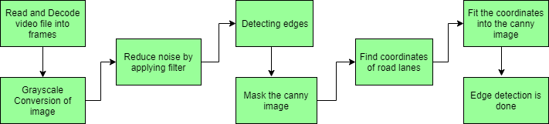

* **References:**
* <https://jivp-eurasipjournals.springeropen.com/articles/10.1186/s13640-018-0326-2#Fig1>
* <https://www.hindawi.com/journals/am/2018/8320207/>
* <https://www.google.com/search?q=methodology+for+lane+line+detection&client=firefox-b-d&sxsrf=ALeKk01GXqXP6_1gFVXzhpVGWMJlfYG2Dg:1626766435899&source=lnms&tbm=isch&sa=X&ved=2ahUKEwjw4qyckfHxAhUH7XMBHaJKC9sQ_AUoAXoECAEQAw&biw=1366&bih=643#imgrc=OnvIckBQXRzuRM>